*Links to just a few of our online interactive workshops being run by our local NE Yorkshire and Humber team.  *NEW workshops July to September NOW live for bookings  *Scan the QR code to book your place.  *Free to all registered pharmacy professionals and trainee pharmacists.  Other workshops available here: Book a workshop (cppe.ac.uk) | 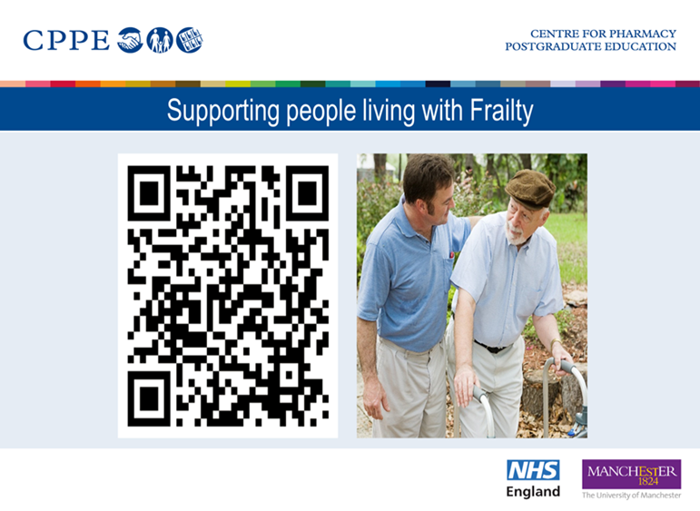  5th June Oliver Fillingham and Matt Auckland  16th July Jenny Graham and Victoria Walker  Supporting people living with frailty : CPPE
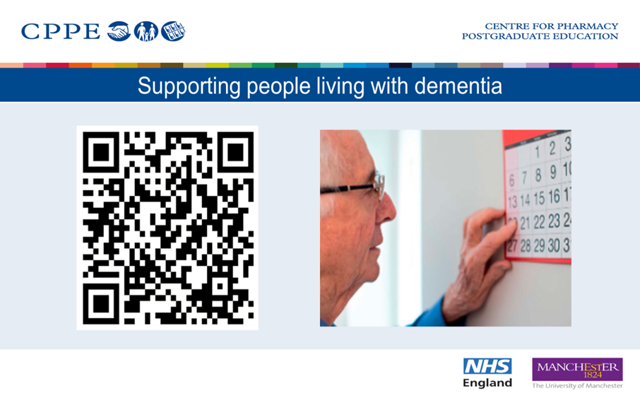  12th June Katie Denby and Kristeen Turner  Supporting people living with dementia : CPPE | 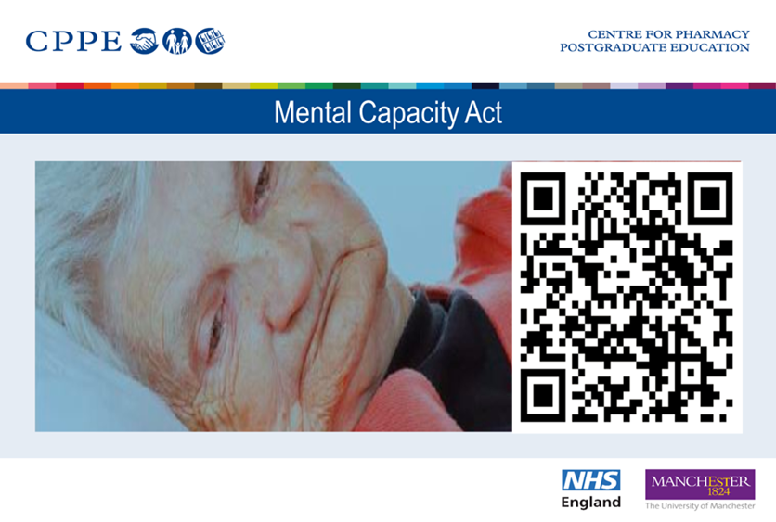  19th June Chris Bonsell and Matt Auckland  Book a workshop (cppe.ac.uk)
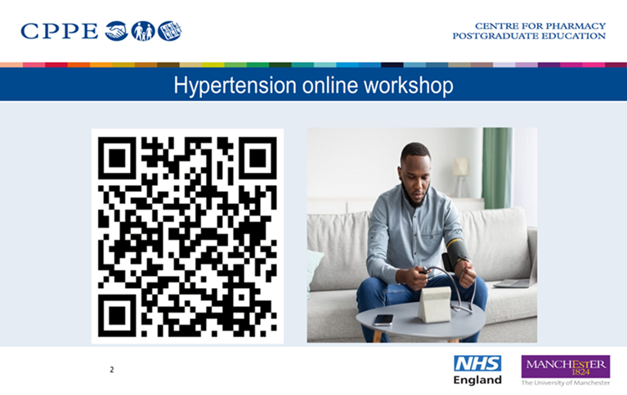  26th June Paul Jenks and Debbie Needham  https://www.cppe.ac.uk/programmes/l/hyper-ew-01 | 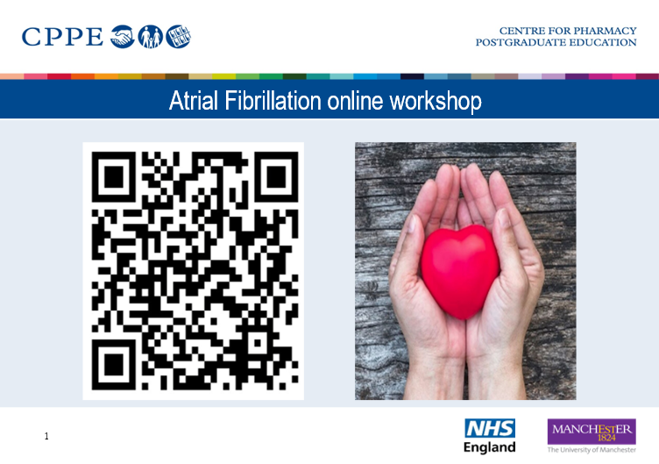  25th June and 19th September Jenny Graham and Kristeen Turner Atrial fibrillation: improve detection and person-centred care - focal point : CPPE
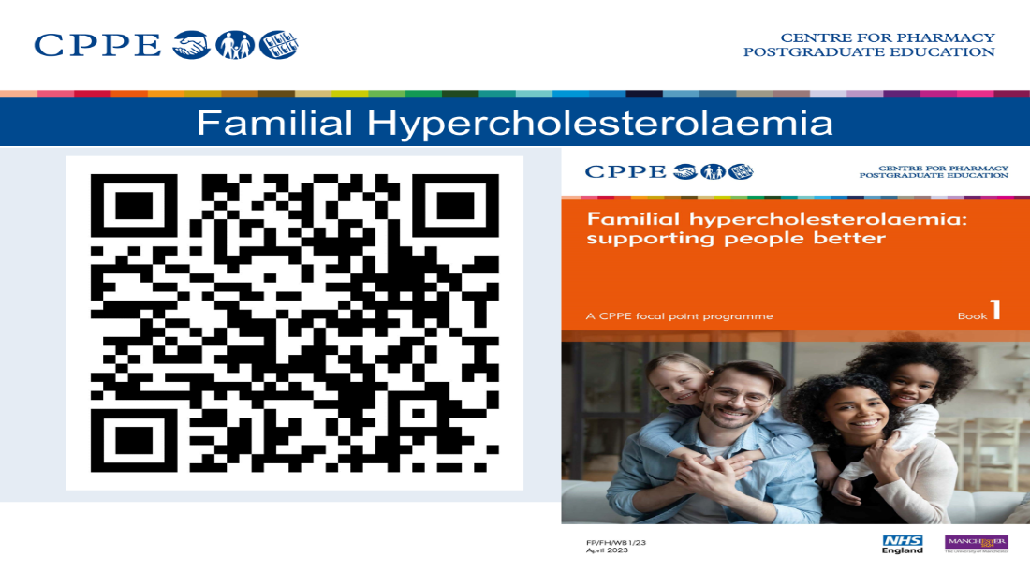  25th September Victoria Walker and Chris Bonsell  Familial hypercholesterolaemia: supporting people better - focal point : CPPE | 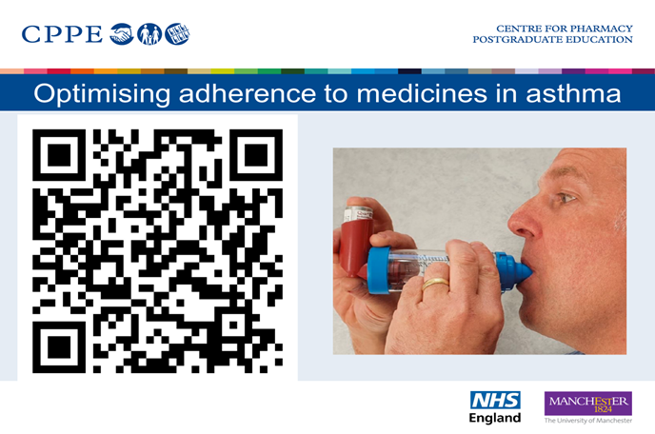  12th September Amy Lake and Jenny Graham  Asthma: optimising adherence to medicines - focal point : CPPE
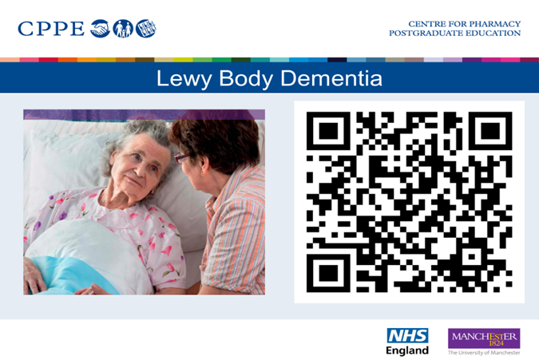  2nd July Katie Denby and Karen Stone  Lewy Body Dementia : CPPE | 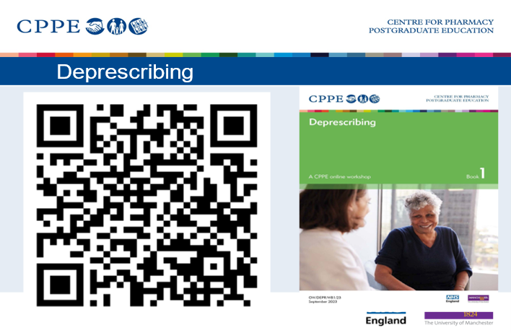  5th July Matt Auckland and Kristeen Turner (afternoon)  Deprescribing : CPPE
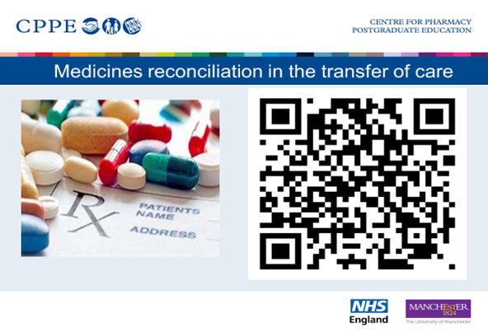  10th July Kristeen Turner and Chris Bonsell  Medicines reconciliation in transfer of care - Optimise : CPPE | 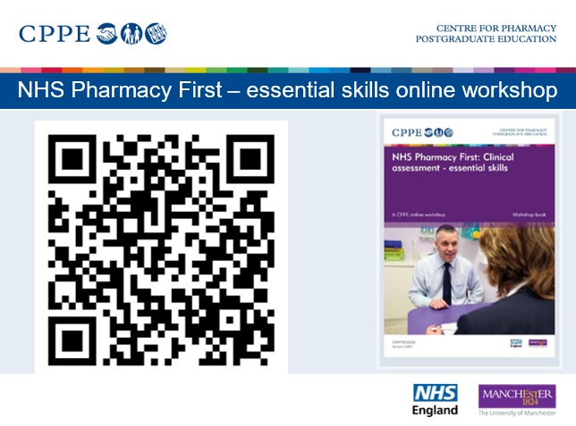  15th September Karen Stone and Oliver Fillingham  NHS Pharmacy First: Clinical assessment – essential skills online workshop : CPPE

For more information about any CPPE workshops and resources see www.cppe.ac.uk. or contact Debbie Needham, Regional tutor Yorkshire and Humber Deborah.needham@cppe.ac.uk or Kristeen Turner, Regional Tutor North East Kristeen.turner@cppe.ac.uk

